Since I have had good luck with my swap except for a few minor bugs I thought I would spend some time and do a writeup on the subject.
Swap Motor = 2.0 16v Engine Code 9A Passat Motor.
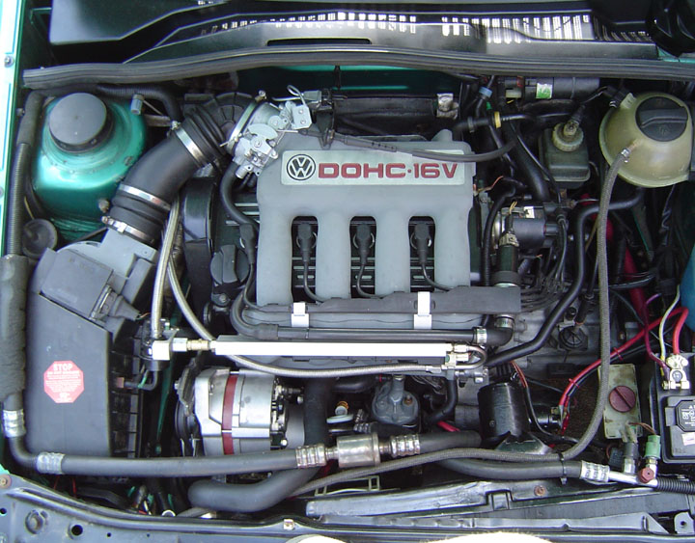
Older Pic that is missing the new intake pipe but good enough. The pipe on there is the plastic 16v stock pipe cut down.
8v parts needed from old motor.
Fuel Injector's
Fuel Pressure Regulator
Knock Sensor
Blue Coolant Sensor ( this is a topic of debate more info below )
Single Sensor Coolant Flange on side of cylinder head
8v Throttle Body
8v Coil
8v Fan After Run Switch
Digi2 Airbox
Vanestyle Air Meter (VAM) (on airbox)
Airbox to Throttle Body Tube
Idle Stabilizer Valve (ISV)
8v Tranny (optional see below)
8v Lower Radiator Hose
8v Heater Core Hoses
All 8v Pulley's
Digi2 Injector Cups
Keep all of the 8v hoses and various bits until your done cause they come in handy for custom stuff.
16v Parts to keep
16v Motor Complete
16v Tranny (optional see below)
16v Alternator
16v Rubber Throttle Body Elbow
16v Brake Booster Vac Hose
16v Throttle Cable (see below)
16v Distributor
16v Plug Wires
16v Upper Radiator Hose
16v Coolant Pipe
16v Sensor's (keep them all for now)
16v Oil Cooler and Filter Flange
16v Exhaust Manifold and Gasket's
Keep all of your 16v Hoses and bits for now too cause you never know.
Things You Have to Buy
The Bentley Manual (optional but highly recommended)
Fuel Rail (Ross or BBM or Homemade whichever works for you)
Fuel Pressure Regulator Mount (usually you can order it with your rail or use an aftermarket regulator)
Replace all non reusable stretch bolts (refer to Bentley)
Clutch Pressure Plate Bolts
Flywheel Bolts
Crank Pulley Bolt (if removing Pulley)
CV Joint Bolts
Cylinder Head Bolts
Connecting Rod Bolts
Things I Recommend You Replace or Buy
Spark Plugs
Plug Wires
Dist. Cap and Rotor
Timing Belt
Timing Belt Tensioner
Sensors (see below) Coolant Temp Sensor, Oil Pressure Sensors
Water Pump
Thermostat
Vacuum Hoses
V-Belts
Fuel Filter
Air Filter
Oil Filter
Oil
Fuel Hoses
Injector O-rings
Motor Mounts (which ones you use depends on which brackets you keep, see below)
Clutch Disc
Change Tranny Fluid
New Ground Wires
New Power Wires
O2 Sensor (8v)
Every shifter bushing
Air Fuel gauge
CV Joint Gaskets
CV Joint Grease
Front Subframe Bushings
Steering Rack Bushing
Copper Exhaust Manifold and Cat. Nuts
Magnetic Oil Drain Plug
Oil Drain Plug Seal's
Oil Pump
Digifast Chip from VW_Pilot on the tex
Special Tools
Clutch Disc Centering Tool
Shift Gate Alignment Tool (or print out its picture and make a cardboard one.
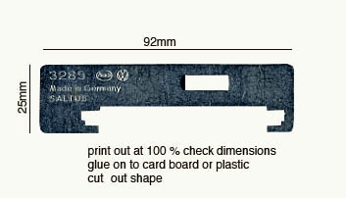
8mm 12 Point wrench for CV joints
12 Point Metric Sockets for clutch pressure plate bolts
Timing Belt Tensioner Tool (can use snap ring pliers)
17mm Hex Tool for Tranny Drain Plug
OK just some basic stuff that I think you should do during this swap.
Label all of your electrical connections and where they connect to before you unplug them.
If you do not have the Bentley then draw diagrams of vacuum lines and other hoses.
Replace EVERY corroded connector with a new one or clean them up shiny.
Keep your eyes open for other problems and fix them now while the engine bay is empty and easy to work on.
Shifter bushings replace them all while you can they make a huge difference.
The Info
Tranny
Depending on your situation you can keep the 8 valve tranny or use the 16v tranny but some of the parts are not compatable. If you Notice any leaking gaskets or seals replace them now while it is easy. You may want to consider doing the Throw out bearing, clutch center plate and retaining ring. If you switch to a 16v Hydro tranny the process is beyond the scope of this write up please refer to the tranny forum for more help
If you are keeping your 8v tranny then you need.
8v Front Motor Mount Bracket
8v Starter
8v Flywheel
8v Tranny Tin/Shields
8v Clutch Disc
16v Pressure Plate
Fuel
I recomend an air fuel gauge to keep track of the new motor since Digi2 was never meant to run this motor you wouldn't want to ruin it. A new o2 sensor will decrease the chance of this as well as a Digifast chip from VW_Pilot on the tex.
You have to get a fuel rail cause the 8v one will not work. Be sure to replace Injector' O-rings and if you can swing it injector's. Sometimes the studs that hold the upper and lower manifold together stick out a little and interfere with fuel rails so you should grind them down.
Good time to get new fuel lines while you are at it. The BLUE fuel hardline is the return and should go to the FPR.
I am running the stock fuel pressure regulator and it is fine. Definitly replace your fuel filter cause it is cheap.
See pic above for fuel rail and lines.
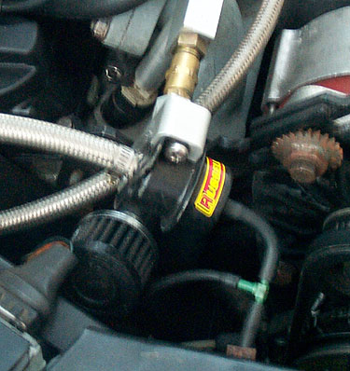
Pic of the FPR
Throttle Body
The idle and wide open throttle switches on the 16v TB do not plug into the 8v harness without modification.
The 16v throttle body that I had came with the restrictor plate on the butterfly and the vacuum connections were not ideal. There was also no idle adjust screw so I went with the 8v.
When using the 8v TB however you have to modify the throttle cable by cutting it shorter and using a wire nut on it, also a piece of rubber hose over it will decrease chafing on the throttle lever.
See the pic below of my intake tube for the wire nut on the throttle cable.
Vacuum Hoses
Definitly replace all of your vac hoses no point in not doing it now it will only give you trouble later. On the 8v TB there are 2 small ports on front and one on back. The front right port goes to FPR and splits off to the airbox as well. The front left goes to the EVAP Valve and so does the rear one. Refer to the Bentley for specifics.
I replaced the 8v Brake booster hose which runs from the intake mani to the booster in favor of the 16v cause it fit better.
Pic of brake booster vac hose from Passat
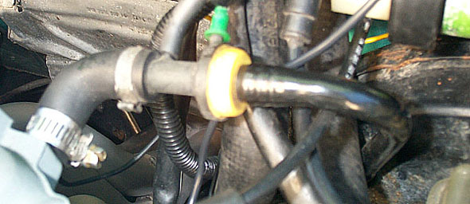
Intake
You will have to rig something for your intake tube. You can use the 8v rubber one but the fit is not ideal. I used the 16v rubber elbow and a piece of aluminum tube and a silicon turbo style boot to fabricate my own. The aluminum tube came from a turbo volvo for 5 $ I just cut it at one of the bends to give it the correct shape.
Depending on how you run your ISV hoses you may need a port on it but I ran my ISV to the large TB port with a piece of old coolant hose.
Pic of my new intake tube.
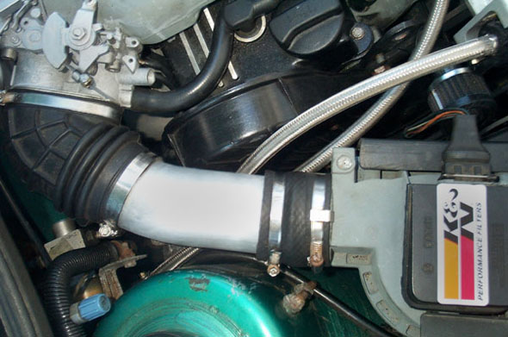
ISV
As far as I know the 16v and 8v ISV's are not compatable but you can simply swap one for the other and put the 8v one in the stock 16v location and use the same hoses. If I remember right one the hoses was a little big so I had to tighten the hose clamp really good but nothing major.
Here is a pic
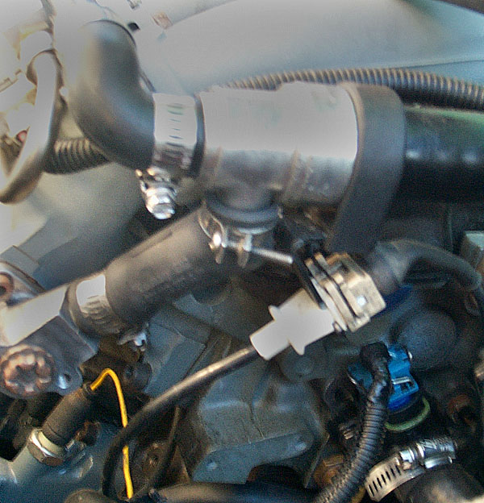
This is the hose I used to connect the ISV to the TB, I used the stock 16v plastic pipe and the hose is an old coolant reservoir hose.
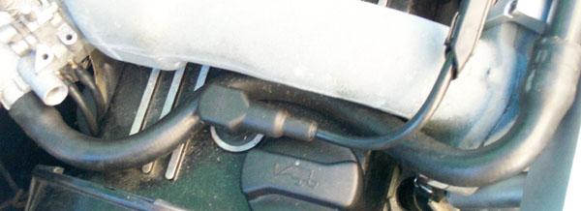
Cold Start Injector
I removed mine completely and threaded a large bolt into the hole with some sealant. A block off plate would work too or you could even just leave it there unplugged.
See pic of ISV for the bolt in the cold start injector hole
Hoses
I used the 8v lower radiator hose with the 16v upper radiator hose and a Passat 16v coolant reservoir hose cause the 8v and 16v hoses were not long enough. I think the metal coolant pipe from the Passat is slightly different which is why. The rest of the hoses were 16v hoses except for the heater core hoses which were from the 8v however I had to cut the hose that goes into the side of the 16v head cause it was too long so maybe the 16v heater core hoses would have worked better.
My crank case breather hose I decided to not reconnect to the intake stream cause I didn't want all that carbon build up in my freshly rebuilt motor so I put a minifilter on the end and capped off the vac lines from the manifold. I don't have much blowby in the new motor so oil spatter out the end of the filter is not a problem however I think there are some advantages in horse power when you create a vacuum in the crankcase so I am researching that further.
You can see the K&N minifilter on my breather hose under the FPR pic above. UPDATE: This etup has proven to be messy even with my windage tray I still get oil vapor. I reccomend either a catch can or piping the crankcase vent hose back into the intake system.
Sensor's
There has been some debate over whether or not to use the stock Digi2 CTS vs. stock 16v CTS and I have run some tests to see for myself. According to the Bentley they are electrically compatable. I took both sensor's and heated them up in water with a thermometer and took readings off both. They gave the same readings as predicted. However if you wish to use the DIgi2 sensor you will have to use the single sensor coolant flange off the side of the 8v head and put it on the 16v head. Mine fit with no modification but I do not have the 16v thermotime switch installed so the hole is plugged and I had plenty of room for the flange.
I also have the stock 16v CTS installed and when I take reading off of them while they are both in the car I get slightly different readings from one to the other which I attribute to there locations. The difference is not substantial and they both fall within the Bentley's specs so It is really up to you but they are compatable.
The Temp sender for the temp gauge on the dash you should use the 16v one and just cut the digi2 connector off and use a spade terminal. The brown wire is ground so connect the other one or test for voltage when the key is on and use that one.
Replace your oil pressure switches cause they are cheap insurance but I recommend moving the low pressure switch to the back of the cylinder head where the oil temp sender is located and moving the temp sender to the oil filter flange. The head will lose oil pressure earlier which is why I moved it.
The radiator fan after run switch is located on a bracket on the back of the 8v valve cover just remove it and put it on the 16v vallve cover above the exhaust manifold.
All the sensor locations including the digi2 single sensor coolant flange.
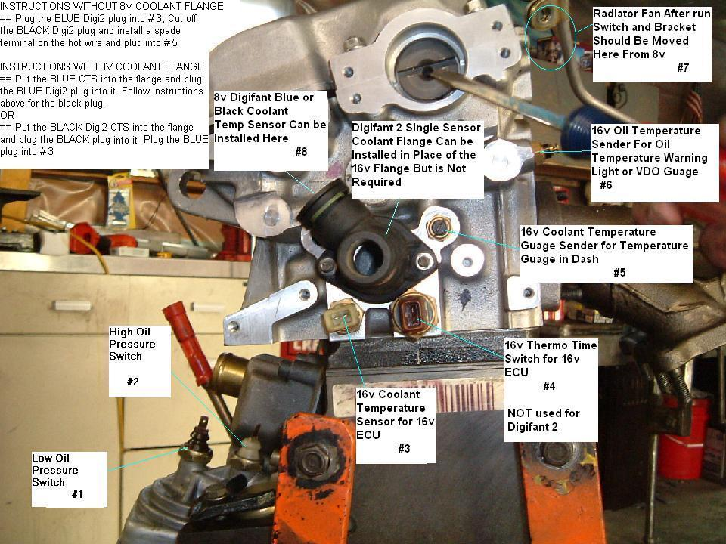
Radiator fan after run switch mounted above header or exhaust manifold.
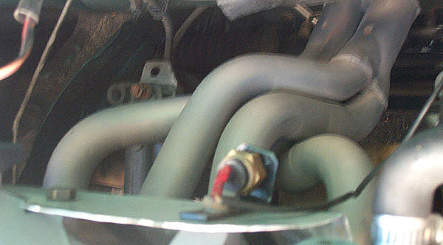
Ground Wires
Digi2 is really sensitive to bad grounds so replace all your ground wires and clean up or replace connectors. You should have grounds running from battery to body and then to tranny. I ran one from tranny to cyclinder head as well. There is also a ground from the coil bracket to the valve cover.
O2 Sensor
Digi2 is also sensitive to a failing o2 sensor so replace it atleast every 60k miles. Alot of Digi2 problems can be fixed by replacing the o2 sensor.
Distributer
Pretty much plug and play, the Digi2 connector plugs right in. I had an issue with a bad Hall sender when I originally did my swap but I think it was just bad so I swapped in the Hall sender from my 8v Dist. . It is possible that this has to be done on all of them cause I have heard other people having to do the same thing but I don't have any hard evidence to back it up.
Fuel Injector Harness
The old harness is not long enough to reach around to the front of the 16v so I soldered ina couple short length's of wire to make it reach. Be sure your connections are waterproof and don't bother with butt connector's cause this is not the place for them. If you do not know how to solder you can buy no crimp butt conector's that solder the wires for you with the help of a lighter. NAPA carries them but so do other auto parts stores.
I chose to keep the plastic loom that covers the injector wires, I split it open and drilled a couple holes through one half of it that would line up with the holes in the bottom of my Ross Fuel Rail and mounted directly to the rail. Looks perfectly factory. Putting the connector's one the injector's can be a real bitch no matter how you do it so be patient.
Here is a pic of how I mounted the injector harness loom to my Ross rail.
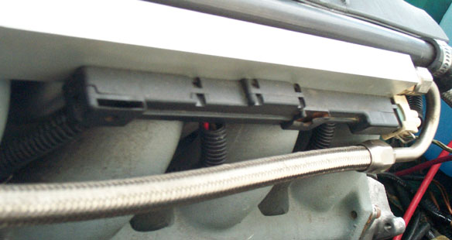
Exhaust
The 16v and 8v exhaust manifolds are not compatable, the Passat 16v manifold is different from the GTI 16v manifold as well. The dual downpipe from the GTI 16v is the same as the dual downpipe from the GTI 8v however the Passat 16v dual downpipe is not the same.
According to a few other people here on the tex they have used the Passat manifold and downpipe without any problems.
Another option of course is to use a header which should be for a GTI 16v.
Everything else after the Manifold/Downpipe can be reused from the 8v.
Alternator
16v and 8v alternator's are not compatable because the mounting brackets are different. Use the 16v one.

Pulley's
Depending on whether or not you have AC determines which pulley set you use. They are completely different. To correctly remove AC you must change the small pulley on the crank, the waterpump pulley, and the alternator pulley and if I remember correctly the power steering pulley as well. The only one that stays the same is the large crank pulley. It is possible to make things work and many people have done it but since my 16v originally came with no AC I had to change them all in order to add it.
Motor Mounts
The motor mounts should all be replaced at this point since the 16v is a more powerful motor any questionable mount from the old 8v will be no good when the 16v starts pulling on it. Which mounts you use depends on the brackets you have. There are hydraulic front and rear mounts or solid mounts and they have different brackets so make sure you order the correct ones.
Tuning
Tuning is all done to the Digi2 specs so follow the procedure in the Bentley. The 16v does seem to like a slightly higher idle though.
I have been experimenting with tuning the VAM spring but small adjustments really don't seem to make a difference. I am not sure how the idle mixture is or whether it should be asdjusted since I do not have access to smog equipment.
That is all I can think of for the moment but I will be updating pictures soon as I take them.
For a MKI there are a few extra things to add to that. Yes, some MkI's were digi2. Mine for instance. 1993 VW rabbit Cabriolet.
- Re-use all MKI mounts. They will all work.
- Must use scirocco 16v manifold and downpipe. Passat or MKII manifold/downpipe will not fit.
- It is easier to use scirocco upper intake manifold, as the intake hose and air box can remain on the driver side. However, a passat or MKII upper manifold will work, you just need to make some room on the passenger side.

